**ME 5751 – Design and Manufacturing of Compliant Mechanisms and Robots**

**Autumn, 2025**

**Project Description**

**Project Goal:**

* Build a robotic arm with a gripper and complete pick and place tasks.

**Teams:**

The project will be completed by a team of up to 4 students. You are free to select your own teams, but I’ll assist those of you who don’t know anyone in the class in forming teams. You are required to schedule weekly meetings to discuss the design progress.

**Robot arm:**

* LeRobot SO-ARM 101 Follower arm
  + 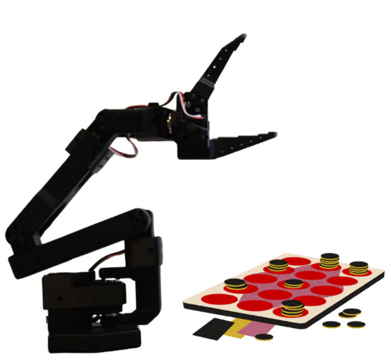6 DOF: 5 for the arm, 1 for the gripper. Six motors: STS3215 12V, 1/345 gearing
  + Price: $190, Ships from the US.

Link to order [**https://partabot.com/products/so-arm101-follower-only?variant=43200383549555**](https://partabot.com/products/so-arm101-follower-only?variant=43200383549555)

* + Bill of materials, CAD models, [**https://github.com/TheRobotStudio/SO-ARM100?tab=readme-ov-file**](https://github.com/TheRobotStudio/SO-ARM100?tab=readme-ov-file)
  + USB Camera: $28, <https://shop.wowrobo.com/products/2mp-usb-camera-module-for-so-arm100-101-30fps-3m-cable?utm_source=chatgpt.com>
  + Documents: assembly videos, [**https://huggingface.co/docs/lerobot/so101**](https://huggingface.co/docs/lerobot/so101)
  + ROS simulation:[**https://github.com/Pavankv92/lerobot_ws/tree/main**](https://github.com/Pavankv92/lerobot_ws/tree/main)
* The controller:
  + Use a PC or a programmable single-board microcomputer such as Arduino, Raspberry Pi, Jetson Nano or similar products
  + Write a kinematic controller of the robotic arm and the gripper.
    - The controller should implement the inverse kinematics of the robotic arm
    - It is NOT allowed to use the teach and play techniques for completing the tasks. That is, the controller algorithm must solve the inverse kinematics in the real time, rather than using the prerecorded joint angles.

**Competition rules:**

**Task 1: Pick and place wooden blocks**

* Goal:
  + Pick and place a variety of objects from one position to another
  + Pick and place as many as possible objects in a given time window (**about 90-120 seconds**)
  + The robot should be pre-programmed to conduct all tasks. Once it is set, no one can touch the robot or the object.
* Scoring:
  + A pick/place task is successful if the object is placed in the designated container box.
  + Each successful pick/place task is counted 10 points
  + The total score is calculated as the total number tasks times 10 points
* Field setup:
  + Field dimensions are shown in the figure below

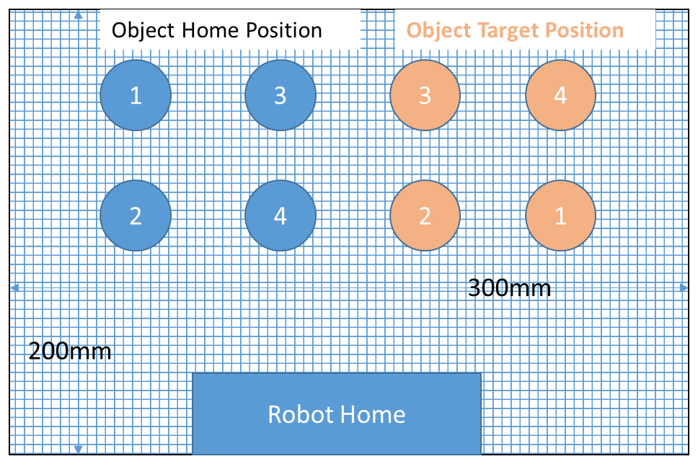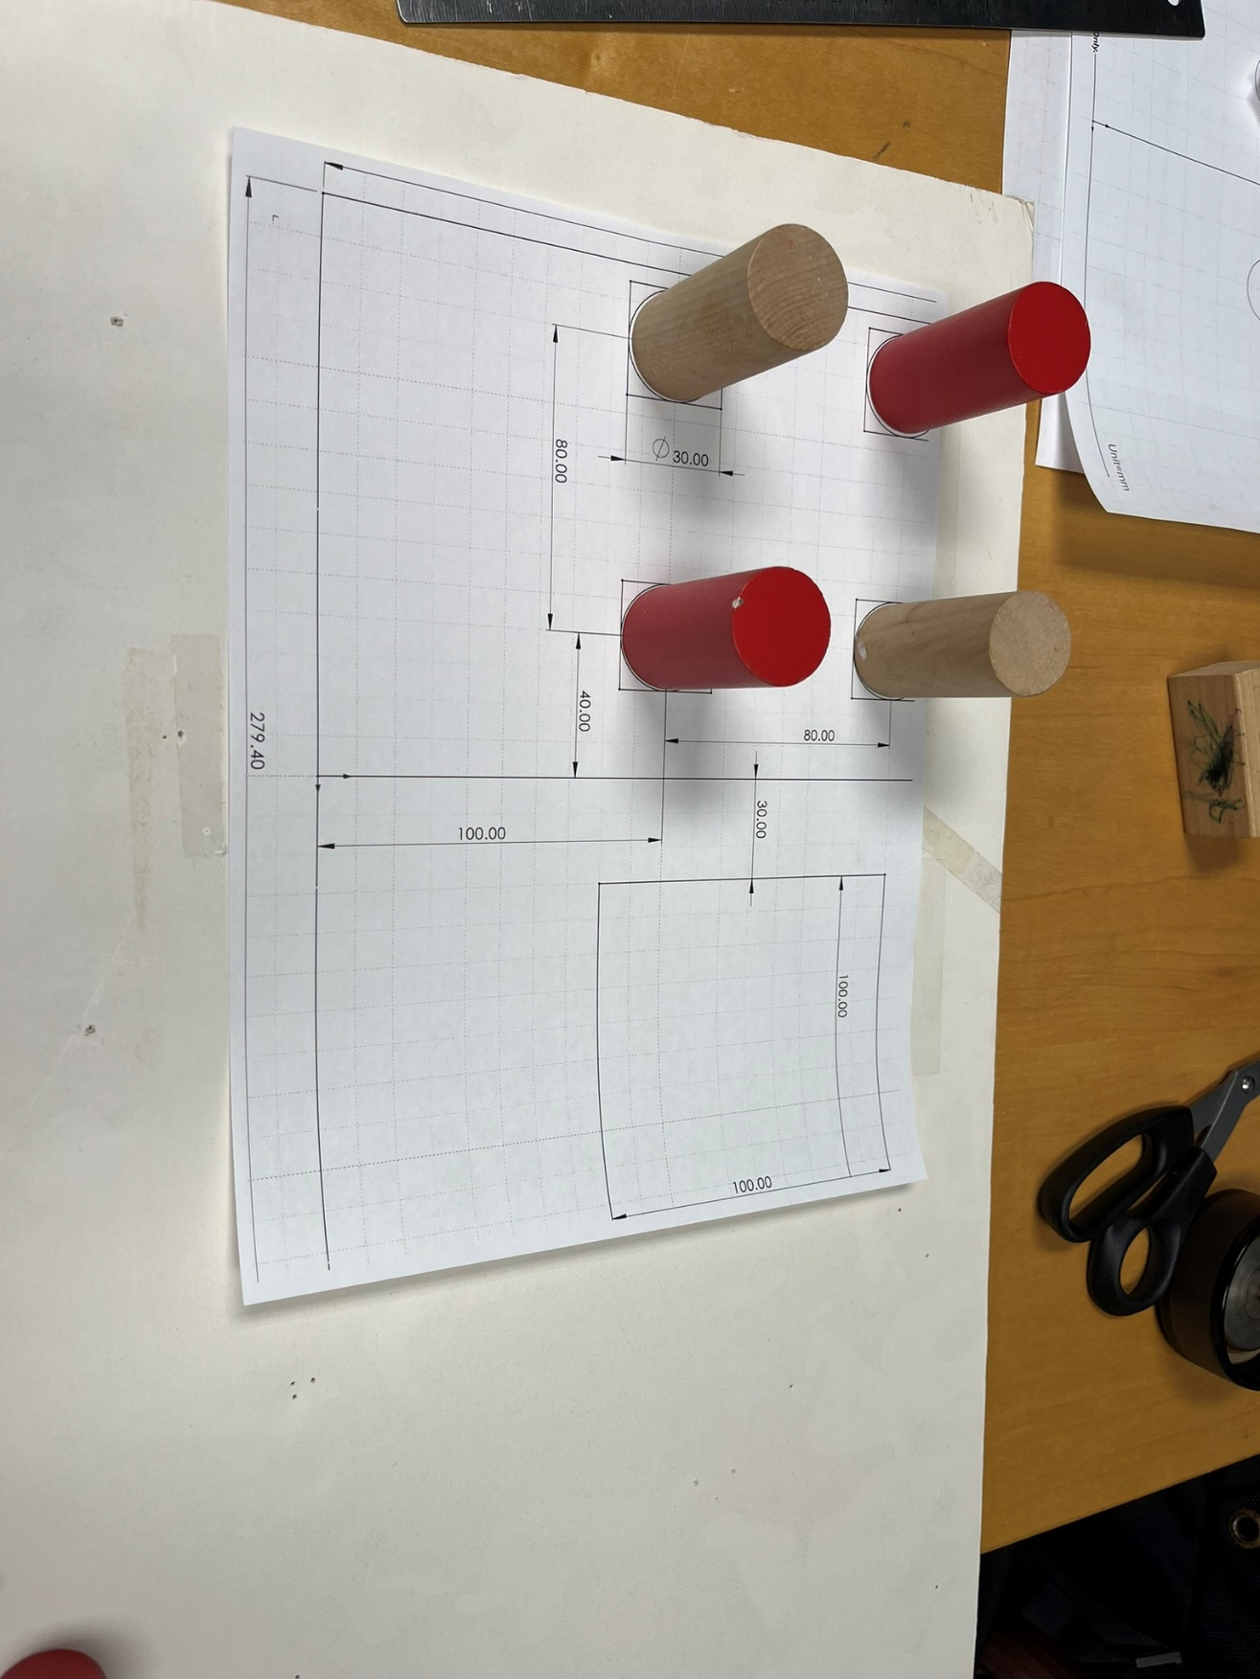

* + The sizes and coordinates of the objects are known. Objects can be a random mix of wood toys, triangles, cubes/cylinders  
    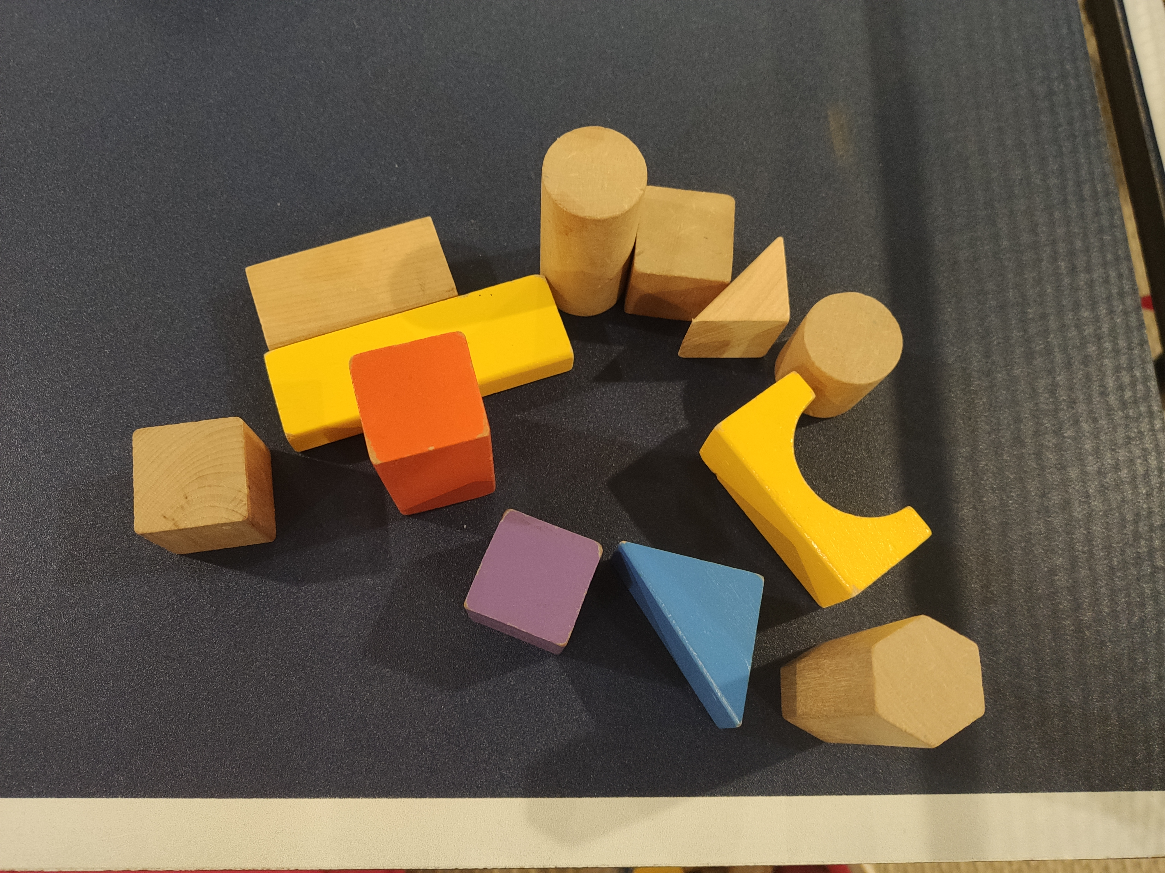

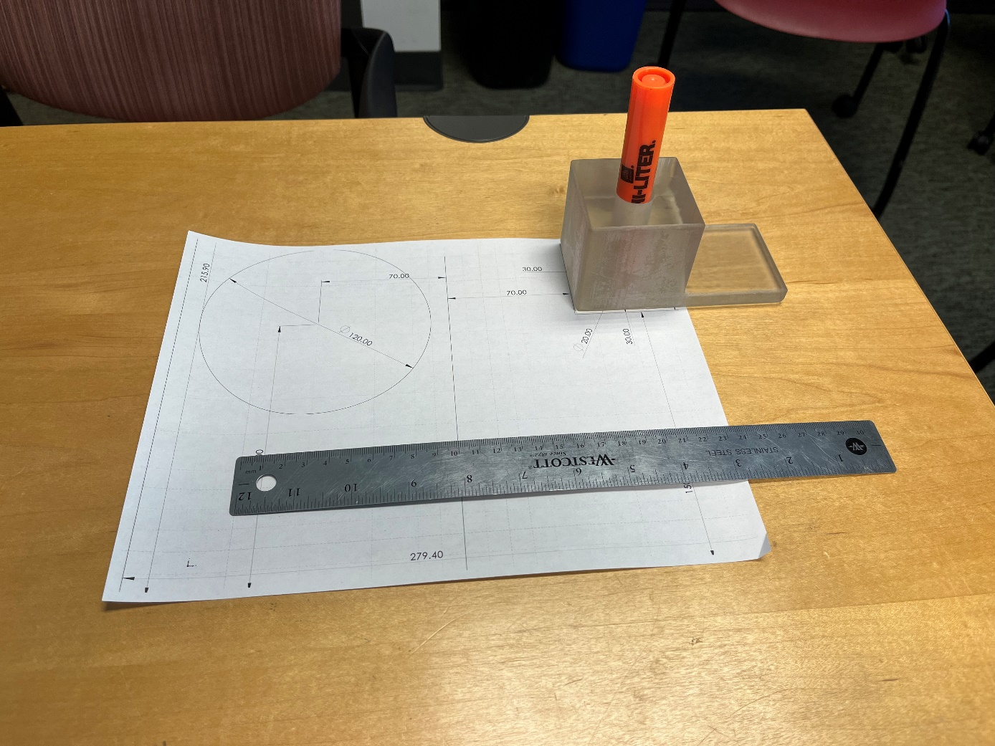**Task 2: Pick a marker pen and trace a curve**

* Goal:
  + (20 points) Robot grasps a marker pen (see dimensions from the previous slide) from a pen holder:
  + (40 points) Robot move the pen tip to trace a curve (e.g. circle) on a field paper (letter size) (exact dimensions will be given)
  + (20 points) Robot place the marker back into the pen holder
* Total time: 120 secs
* Maximum points: 80
* Field setup:
  + Field dimensions are shown in the figure below

**Task 3: Random placed objects (computer vision)**

* Goal:
  + Robot detects the position of a wooden block that is randomly placed on the field
  + Robot grasps the detected block and place into a designated area.
* Total time: 120 secs
* Maximum points: 80
  + Field setup: same as in Task 1 and 2.

**Final Report Deliverables:**

1) A written paper describing the analysis, fabrication and testing of the robot

2) Pictures and videos showing the testing/operation of the physical prototype.

**Grading:**

* Competition task result: 40%
* Progress reports: 5% (late submission will be subjected in deduction in points)
* Final paper: 5% (completeness of materials, technical writing)

References:

* Youtube Playlist for ME 5751 (Spring 2022) Final Project Competition
  + <https://youtube.com/playlist?list=PLjiZ26l9QIkyiXn23hBsi-Rf1M4ZiOSlU&si=nGxQqdxfMZ-IuwAd>

Servo Motor Control with an Arduino

<https://www.allaboutcircuits.com/projects/servo-motor-control-with-an-arduino/>